
PROJECT DEVELOPMENT DELIVERY OF

SPRINT-4

 | TEAM ID | PNT2022TMID53615
 | PROJECT NAME | SMART SOLUTIONS FOR RAILWAYS

Market Overview:

The growing applications of IOT technologies as well as cloud-based services in various industries have raised the demand for smart railways so as to integrate the new generation services and solutions for their operation. Moreover, the contribution of information and communications technology in smart railways further gives rise to efficient and modern forms of transportation.

The global smart railways market was valued at USD 14,328.9 million in 2018 and is projected to reach USD 48,778.1 million by the end of 2027. In addition to this, the market is estimated to register a CAGR of 14.7% during the forecast period, i.e., 2019-2027.

Growth Highlights based on region during 2017-2027:

The global smart railways market is segmented by regions into North America, Latin America, Europe, Asia-Pacific and Middle East and Africa, out of which, the market in Europe is anticipated to hold the leading share in smart railways market over the forecast period. This can be attributed to the huge investments made by government on smart railway projects along with growing adoption of Internet of Things in this region. The market in North America is anticipated to hold the second largest share on account of upcoming high-speed train projects in the U.S. and Canada. The market in Asia Pacific is estimated to observe a significantly high growth in the upcoming
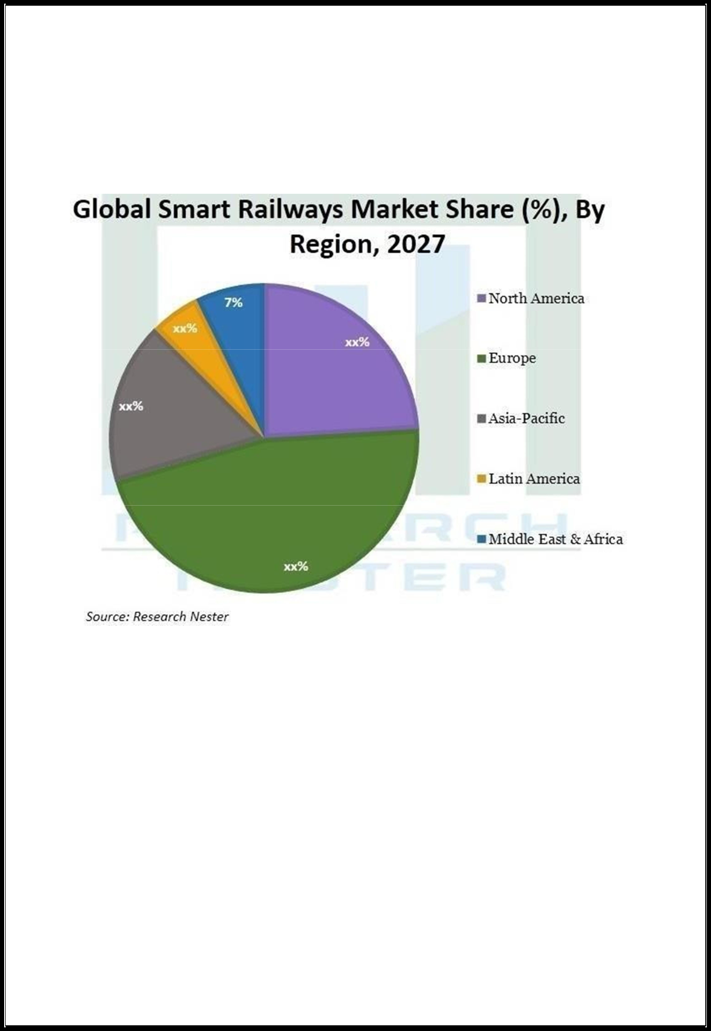
years as a result of rising advancements in the region. For instance, China is focusing on the development of high- speed trains in order to reduce the travel time between railway stations.

